EUCHARISTIC ADORATION GUIDELINES
St. Maximilian Kolbe Parish

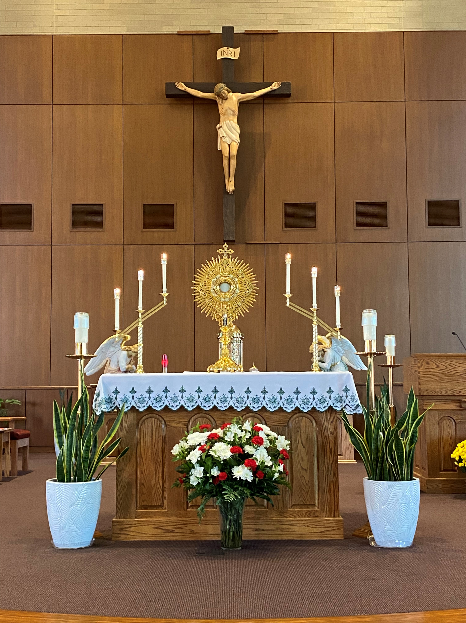
Thank you for your interest in our Perpetual Adoration of the Blessed Sacrament ministry. May Jesus and His Mother bless you.
Adoration is held in the chapel 24/7. Exposition is held in the church Thursdays, First Fridays of the month and Mondays during Advent/Lent 9:15 a.m. until evening Benediction.

Adoration Guidelines:
1. Sign-in Books are located in the foyer of the chapel and on the Usher’s
Table across from the Baptismal Font in the back of church.
a. If you committed to a scheduled time, check the box next to
your name in the Sign-in Book.
b. If you are a substitute, sign your name in the Sign-in Book next
to the adorer’s name for whom you are subbing.
c. If you are not scheduled, sign in on the guest/visitor section of
the page.
2. Adult prayer materials, rosaries and Bibles are available in the foyer
outside the chapel. On a shelf of the Usher’s Table in the church are
materials for adults, a Family Holy Hour box for ages 3-8 years old
and trays of activity pages for 8–11 years old.
3. “Prayed for by Name” binders near the chapel entry and on the
Usher’s Table in the church are for use by all who enter. Adorers are
encouraged to take a moment to pray for parishioners named in the
binder.
4. It is acceptable to quietly use a smartphone or tablet to read from the
Bible, pray the Liturgy of the Hours or for other prayers.
5. All materials placed in the chapel, church or foyer must be approved
by the Parish’s Pastoral Team.
6. Please be respectful during your time before Jesus in the Blessed
Sacrament. As you enter and exit, genuflect or bow towards the Blessed Sacrament. Put cell phones to silent or vibrate mode. Avoid
unnecessary conversation. Refrain from chewing gum, eating, or
drinking unless medically necessary. Be mindful of appropriate
modest attire.

All Adorers’ Responsibilities:
During Exposition, the Host is exposed in a monstrance on the altar. Since Exposition is a liturgical rite, it involves communal prayer, which requires at least 2 people to be present at all times. Adorers arrive for their hour at the top of the hour. If an adorer is more than 10 minutes late and you have additional free time, please stay until another adorer arrives. If you are unable to stay, check with other adorers in the church to see if they can cover until the next adorer arrives. If none of the above works, please go to the office and staff will contact one of the coordinators. If the office is closed, please contact a member of the adoration team. If you are present during Exposition, do not leave until someone comes to stay for the next hour. If Exposition is not being celebrated, there is no need to wait for another adorer to arrive before leaving.
Safety and Emergency Information:
The chapel is under 24-hour camera surveillance. Dangerous situations are rare during Perpetual Adoration. An emergency phone is located in the entry way to the chapel to call 911 if you feel you are in danger.
In the event of inclement weather, check the website (www.saint-max.org) for closure of the campus. On days of Exposition, a member of the adoration team will make every effort to notify scheduled adorers of a cancellation. If Exposition is not cancelled and you are concerned for your personal safety, please contact a substitute adorer.
If you are interested in becoming a regular scheduled adorer, please visit www.saint-max.org/adoration to sign up and view adoration resources. If you have any questions, email adoration@saint-max.org.

