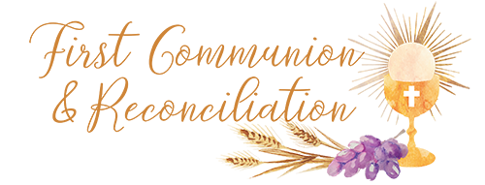

At Home Program
Week # 5 October 9, 2023

“Prayer is powerful! It fills the earth with mercy, it makes the Divine clemency pass from generation to generation; right along the course of the centuries wonderful works have been achieved through prayer.”– St. Francis Xavier Cabrini
Gospel…Matthew 22:15-21…Jesus is Honest and Fair
An adaption of the Sunday Gospel.

Storyteller: In Jesus’ time, the people had to pay taxes to Caesar. He was the ruler of the Roman Empire. Some of the Jewish Pharisees believed that God’s Law told them not to pay these taxes. The coins for paying the tax had a picture of the head of Caesar on them.

Pharisee 1: Jesus, we know you are honest. You say only what is right and true.

Pharisee 2: Tell us, does God’s Law say it is right to pay taxes to Caesar?

Jesus: Show me the coin people use to pay the tax.

Storyteller: One of the Pharisees gave Jesus a small coin.

Jesus: Whose face is on the coin?

Pharisees: Caesar’s.

Jesus: If you have this coin, you should pay the taxes. Give to Caesar what belongs to Caesar and give to God what belongs to God.

Gospel Reflection Questions (not required, but could help with discussion…just a summary is fine)
- How do you show that you belong to God?
- What can we give to God?

Together in Jesus…First Reconciliation Lesson 3…”We Can Act Like Jesus”
- Read pages 1 and 2 which tell of problems that children in Jesus’ time are having. Color in the box for each story that tells what YOU would do.
- Read “Jesus, What Should We Do?” on page 3. What question would you ask Jesus?
- On page 4, “What Does Jesus Teach Us to Do?, write in the voice balloons the words Jesus would say to each child.
- On page 4, “I Prepare for the Sacrament of Reconciliation” Do you act Like Jesus? For each question, write something you can do so that you can answer yes to each question…either something you already do or something you can do in the future.
- Don’t forget to put your stickers on the back page!
We’ll be in Together in Jesus…First Reconciliation Lesson 3 Family Time next week
Any questions? Please don’t hesitate to email me at rburbrink@saint-max.org or call 513-777-4322 ext 124.
Blessings,
Robin

